# Contrast Checks

All the colours used have a sufficient amount of contrast to ensure that they are easily readable. The chosen colour scheme has an 8.59:1 contrast ratio, meaning it meets more the WCAG AA and WCAG AAA contrast accessibility requirements.

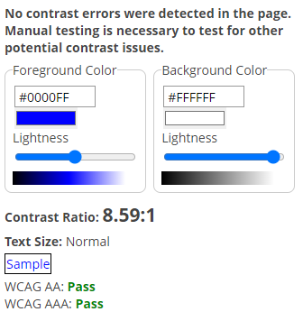

# WAVE Accessibility Checker

The WAVE accessibility checker extension was used to ensure that all pages met accessibility guidelines and didn’t have any accessibility errors.

|  |  |
| --- | --- |
| Index Page | Register: |
| Order Now Page: | Features Page: |

# Skip Links

Skip links were added to every page to ensure that users can skip to the main content on each page. This can be accessed by clicking the ‘tab’ key once the page has loaded.



# Alt Text

Every image on the website has alt so that if the user is unable to see the image, they are still able to get a description of what the image contains.

